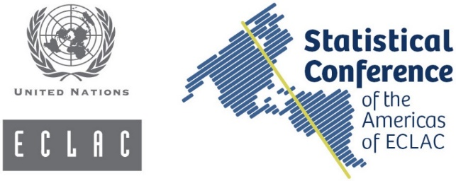

HOTEL RESERVATION REQUEST
TENTH MEETING OF THE STATISTICAL CONFERENCE OF THE AMERICAS OF ECLAC
Santiago, 19–21 November 2019
Nombre/Name: |  | Apellido/Last name:

Dirección/Address:
Ciudad/City: |  | País/Country:
Teléfono/Phone: | Fax: |  | Correo electrónico/Email:
SELECT HOTEL
Hotel Pullman Santiago Vitacura, ex Atton Hotel (****)  Av. Vitacura 3201, Vitacura. Tel: (+56) 2 2422 7902  Single room: US$ 150  (includes breakfast and Internet)  Attn: Carolina Hermosilla, Reservations Department chermosilla@atton.com  reservas-grupochile@atton.com  Group code: 5093557  Block expiry date: 4 November 2019 |  | Hotel Director Vitacura (****)  Av. Vitacura 3600, Vitacura. Tel: (+56) 2 2389 1956  Single room: US$ 125  (includes breakfast and Internet)  Attn: María Eliana Puga and Patricia Crisóstomo, Reservations Department  reservas@director.cl / reservaciones@director.cl  Group code: 434701  Block expiry date: 18 October 2019
Hotel NH Collection Casacostanera (****)
Av. Nueva Costanera 3900, Vitacura.
Tel: (+56) 2 2433 9000
Single room: US$ 150
(includes breakfast and Internet)
Attn: Fabiola Rivera Lagos, Reservations Department fa.rivera@nh-hotels.com
Group code: 1869118
Block expiry date: 18 October 2019
Fecha de llegada al país:  Date of arrival: |  | Núm. de vuelo:  Flight No:
Fecha de salida del país:  Date of departure: |  | Núm. de vuelo:  Flight No:
Autorizo el uso de la siguiente tarjeta de crédito a fin de garantizar mi reserva de hotel /
I authorize the use of my credit card to guarantee my hotel reservation:
American Express | Mastercard | Visa |  | Otra/Other
Núm. de tarjeta de crédito/Credit card No:
Fecha de vencimiento:
Date of expiration:
Please complete this from and send it by email to the hotel selected. Visitors paying in dollars, with travellers’ cheques or with international credit cards are exempt from VAT.

